Name: Mrinalli S
Reg.No: 192411174

Exp.No.01 8 Puzzle Problem
14.07.26

Aim:
To write a Python program to solve the 8-Puzzle problem using the Breadth-First Search (BFS) algorithm.

Algorithm:
- Represent the puzzle as a 3×3 matrix.
- Find the position of the empty tile (0).
- Generate all possible moves (up, down, left, right).
- Apply BFS to explore all possible states.
- Stop when the goal state is reached.
- Display the sequence of moves from the initial state to the goal state.

Program:
from collections import deque
goal=((1,2,3),(4,5,6),(7,8,0))
def move(s):
s=[list(i) for i in s]
for i in range(3):
for j in range(3):
if s[i][j]==0:x,y=i,j
for a,b in [(-1,0),(1,0),(0,-1),(0,1)]:
nx,ny=x+a,y+b
if 0<=nx<3 and 0<=ny<3:
t=[r[:] for r in s]
t[x][y],t[nx][ny]=t[nx][ny],t[x][y]
yield tuple(map(tuple,t))
start=tuple(tuple(map(int,input().split())) for _ in range(3))
q=deque([(start,[])])
v={start}
while q:
s,p=q.popleft()
if s==goal:
for k in p+[s]:
for r in k: print(*r)
print()
break
for n in move(s):
if n not in v:
v.add(n)
q.append((n,p+[s]))

Input:
1 2 3
4 0 6
7 5 8
Output:
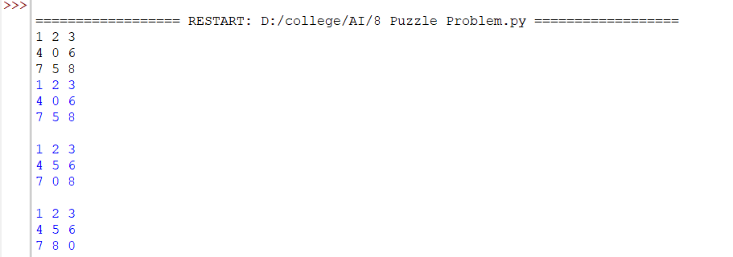
Result:
Thus, the Python program to solve the 8-Puzzle problem using the Breadth-First Search (BFS) algorithm was implemented successfully, and the goal state was reached.

